Applied filters used for the Construction report (recently modified based on feedback from Linda & Hasan)

* Minors:
  + CM07 - **CML Fixed Construction**
  + CM08 - **CML ARM Construction**
  + CM79 - **Participation in Construction**
  + CM81- **Construction to Perm**
  + ML02 - **Construction Master Line**
* FDIC Call Code
  + OTCN - **Other Constr**
  + CNFM - **1-4 family/Res/Construction**

When I filter down active/NPFM accounts under the above criteria, here is the distribution of call codes

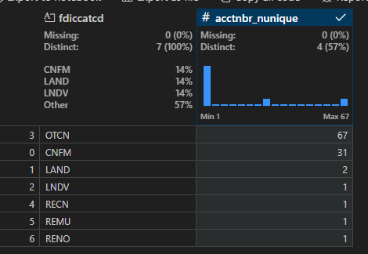

This is not a perfect 1:1 match with the call codes previously used for this CRE presentation:

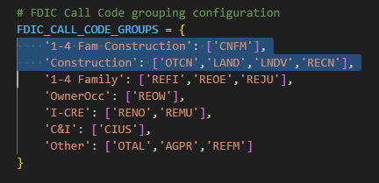

The two outliers are:

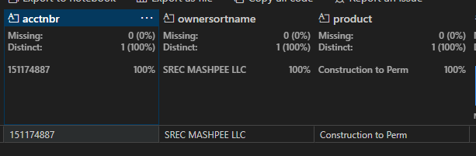

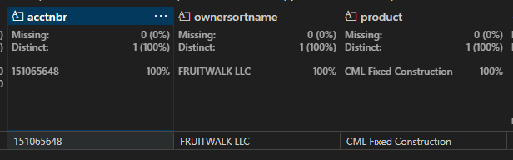

They show up on the monthly construction report, but not on CRE presentation data (due to the way we code Construction above).

Also, just to confirm, we don’t want CNFM included in this construction breakdown of this CRE presentation, because those are 1-4 family construction (CML, but outside the scope of this).